**City of Des Moines Property Analysis Criteria and Process**

Analysis of roof, siding, windows, doors, front porch and stoop, entry way and finally the driveway. Some focus on landscaping overall. Scoring is based on a scale of 1-5 where –

1 is excellent condition, with signs of investment and pride in the home’s upkeep shown by well-maintained landscape, prominent curb appeal, visually attractive house number and doors design/color, high quality external lights, and other aesthetic touches.

2 is good, where structure is in good condition, basic maintained landscape, but needs a few visual touches to make the property visually attractive

3 is average – nothing inherently bad with the structure, but no signs of active maintenance and care

4 – starting to show signs of distress with at least 1-2 red flags

5- is fairly distressed and approaching public nuisance that requires major repairs to make the house better.

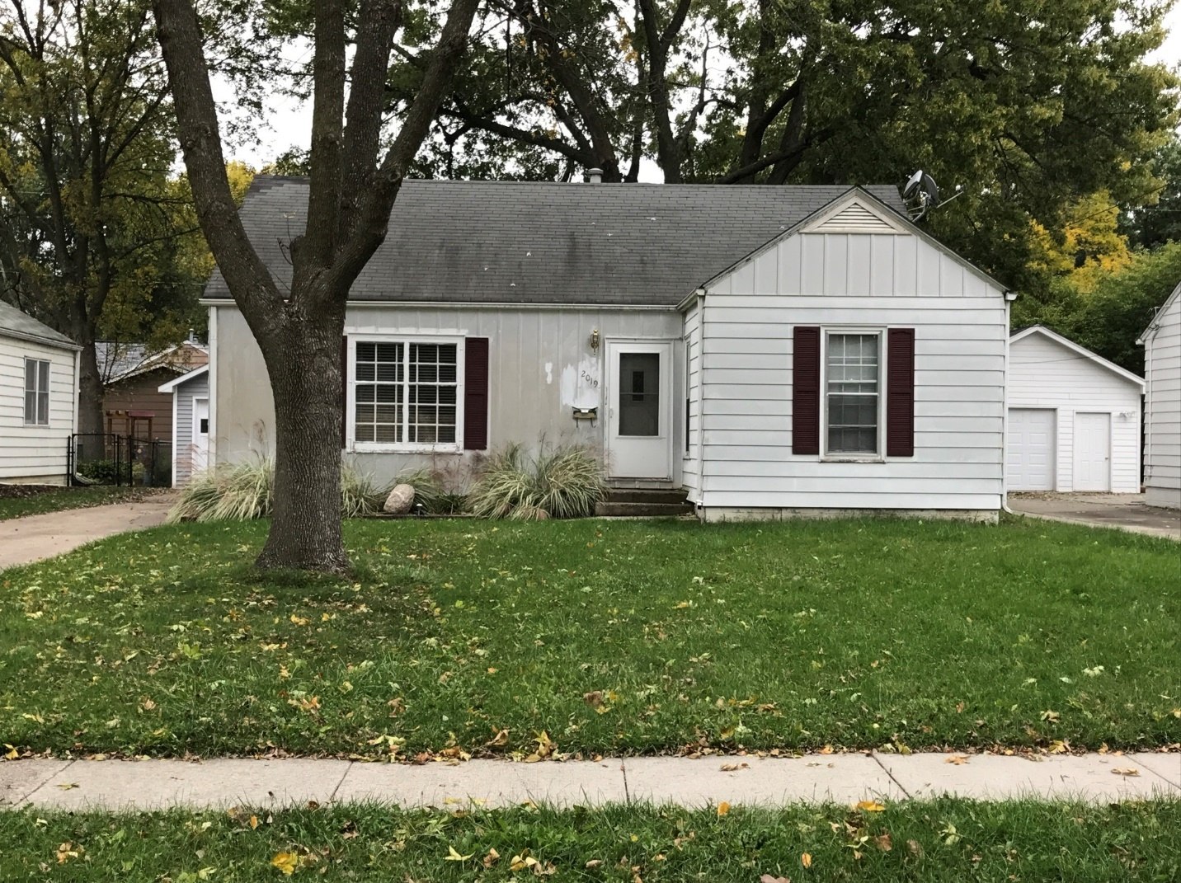

Always start observing the roof when visible. Look for signs of distress like warping, broken or damaged shingles, any damage or signs of distress to gutters, fascia, any chimneys and in this case, also the downspouts. In this case, the roof appears to show some signs of distress and being worn out. What appears are signs of fatigue and wear.

The siding in the front looks worn out, unclean and has a peeled patch on the left side of the front door.

The window on the right show distress at the sill level. The window on the left also shows distress on the sill level with the wood board showing peeled paint.

The front door shows distress towards the base.

Front steps on the stoop seem to show some uneven settling.

Conclusion – Given more than a couple signs of distress, the score is 4.

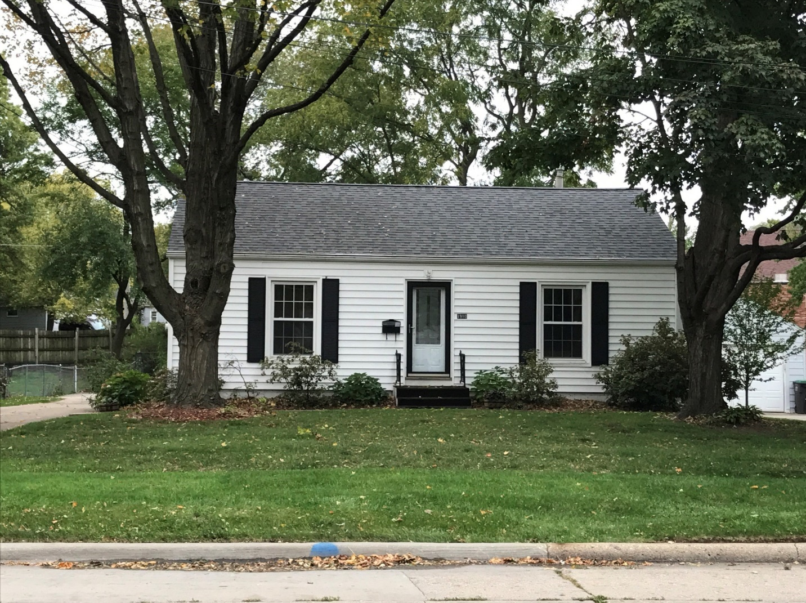Always start observing the roof when visible. Look for signs of distress like warping, broken or damaged shingles, any damage or signs of distress to gutters, fascia, any chimneys and in this case, also the downspouts.

In this case, the roof looks alright with no visible signs of damage or wear and tear

The siding looks clean and in decent condition

The windows look clean and who no signs of damage or distress

The front door and steps look alright.

Landscape is minimal with no major sign of lack of maintenance.

The property is not bad but doesn’t show any extra effort made to improve curb appeal.

Conclusion – Given decent condition of property, the score is 3.

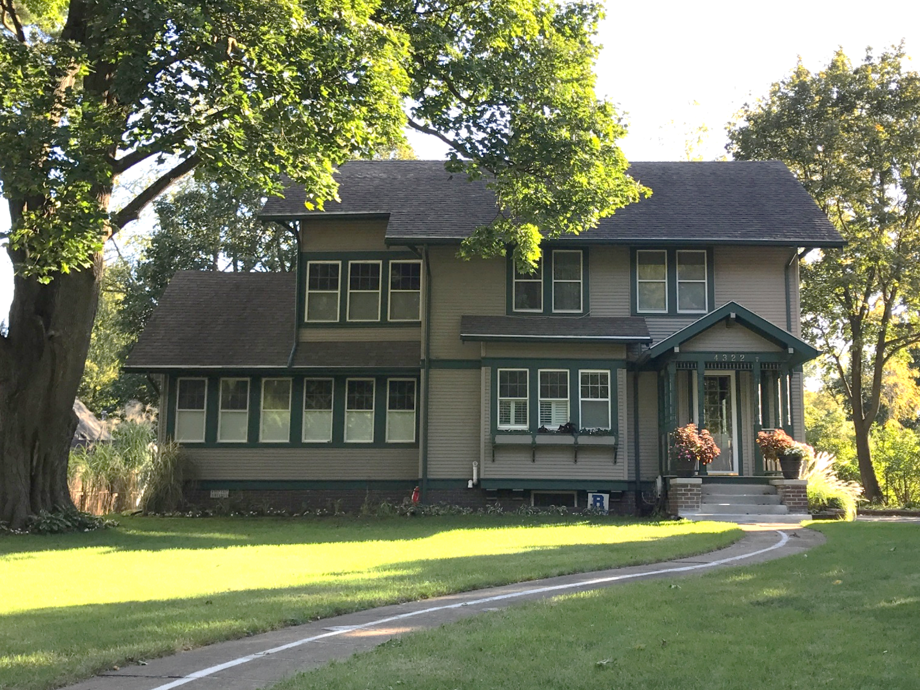Always start observing the roof when visible. Look for signs of distress like warping, broken or damaged shingles, any damage or signs of distress to gutters, fascia, any chimneys and in this case, also the downspouts. In this case, the roof appears to be in good condition.

The siding looks clean and in good condition.

The windows are in clean and good condition, with good quality trim around. It is painted in a way to make it visually appealing.

The front door and stoop are in good condition. House numbers are prominently displayed in good design and material.

Landscaping is basic but well maintained. There are well maintained display pots in the entryway.

Walkway looks in good condition.

Conclusion – Given excellent condition of house and also details that show someone is actively taking care of the property and adding visual elements to make it appealing, the score is 1.

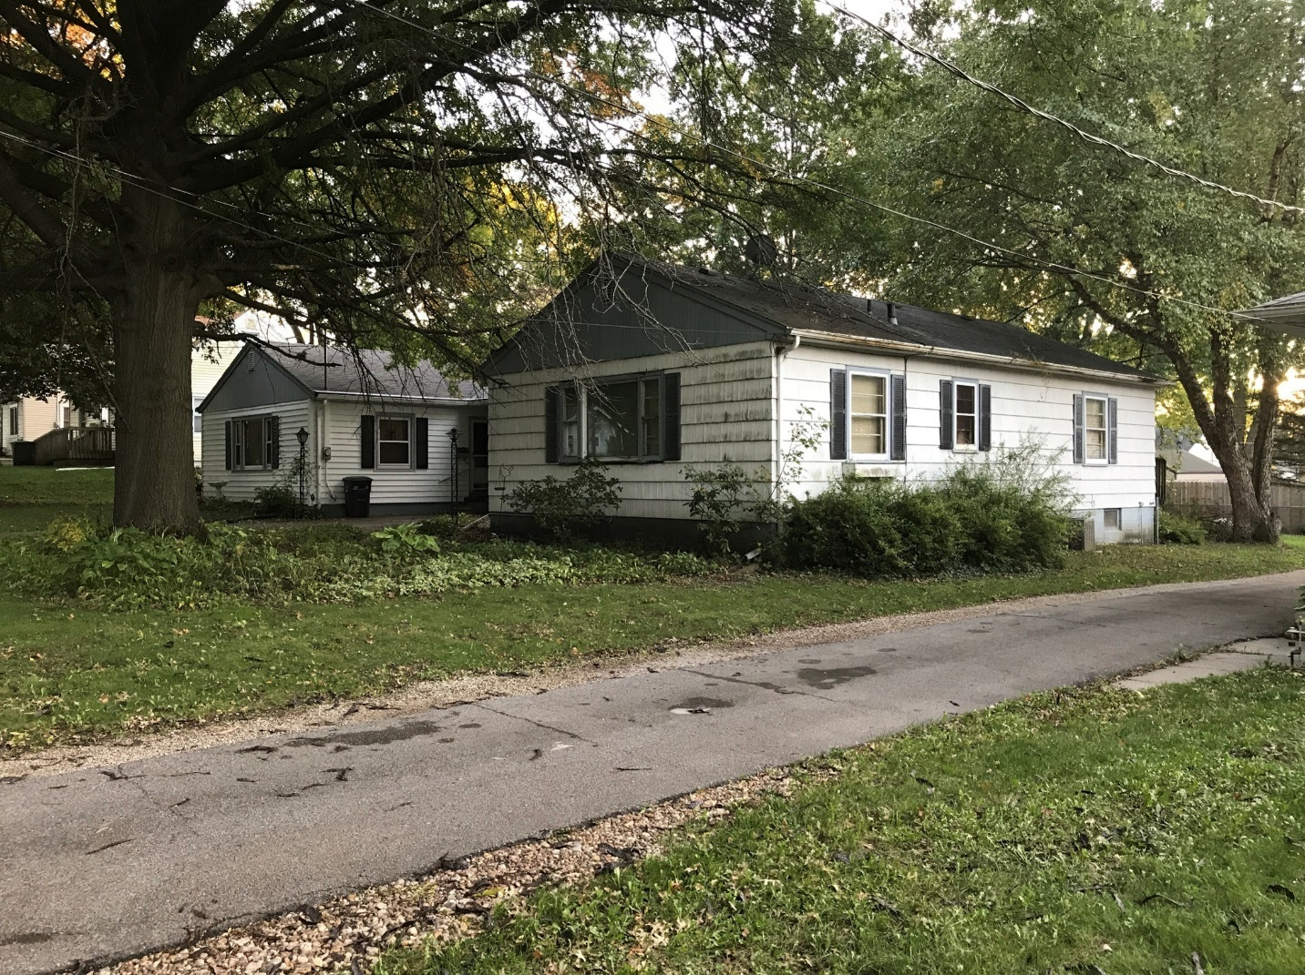

The roof appears to be in bad condition. Thre are signs of wear and tear, with maybe some water drainage on the main roof. The gutter is in poor condition, rusted and damaged especially on the right side of the house.

The shake siding in the front of the house is in poor condition, peeling and dirty. The siding on the rest of the house especially on the right looks distressed.

The window frames are distressed, with the bottom sill showing peeling paint and maybe water damage. The window shutters are in poor condition. Right windows look boarded

House number is not visible.

Landscaping is limited with overgrown bushes on the right and ill-maintained yard.

Conclusion – Given more than 2-3 red flags, the score is 5.

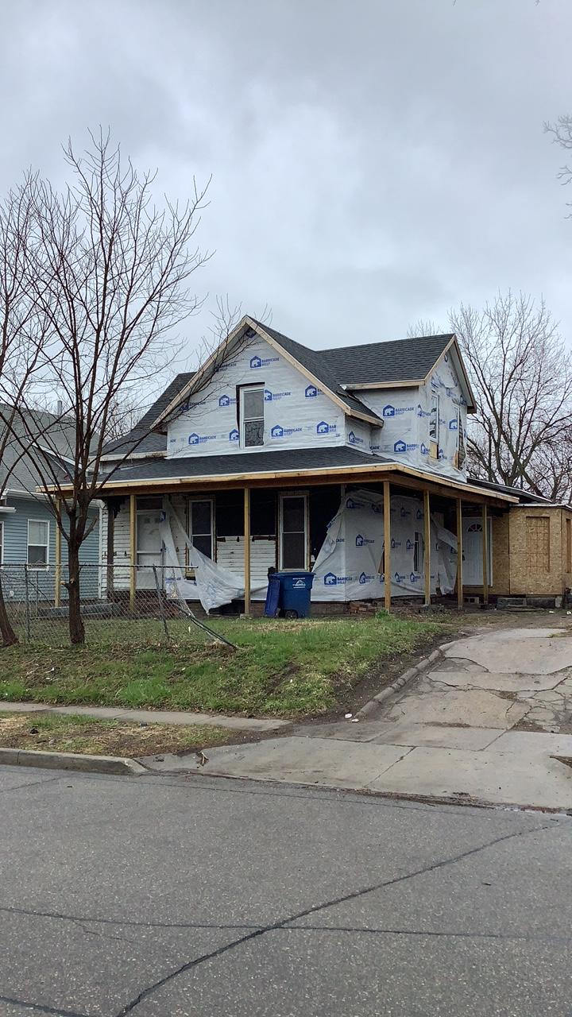

The roof shingles look ok, but the fascia is exposed and unfinished. There are no gutters or downspouts. Roof is in poor condition.

The visible siding on first floor level is in poor condition, especially as seen under the porch. It is peeling and the material is dirty and damaged. The siding on first and second floor is covered in Tyvek and shows signs of very poor condition. There seems to be an addition on the right and back that is exposed, with no siding and is boarded up

The windows are in poor condition, being boarded upon second floor, absence of trim on all windows and peeling wood in poor condition.

The front door is not completely visible but shows poor condition. The porch roof and columns are unfinished and in poor condition.

No visible effort in landscaping, lawn is not maintained. Driveway is cracked and broken and in poor condition.

Conclusion – Given poor condition with more than 2-3 red flags, the property is bearing a public nuisance and unsafe for habitation. The score is 5.

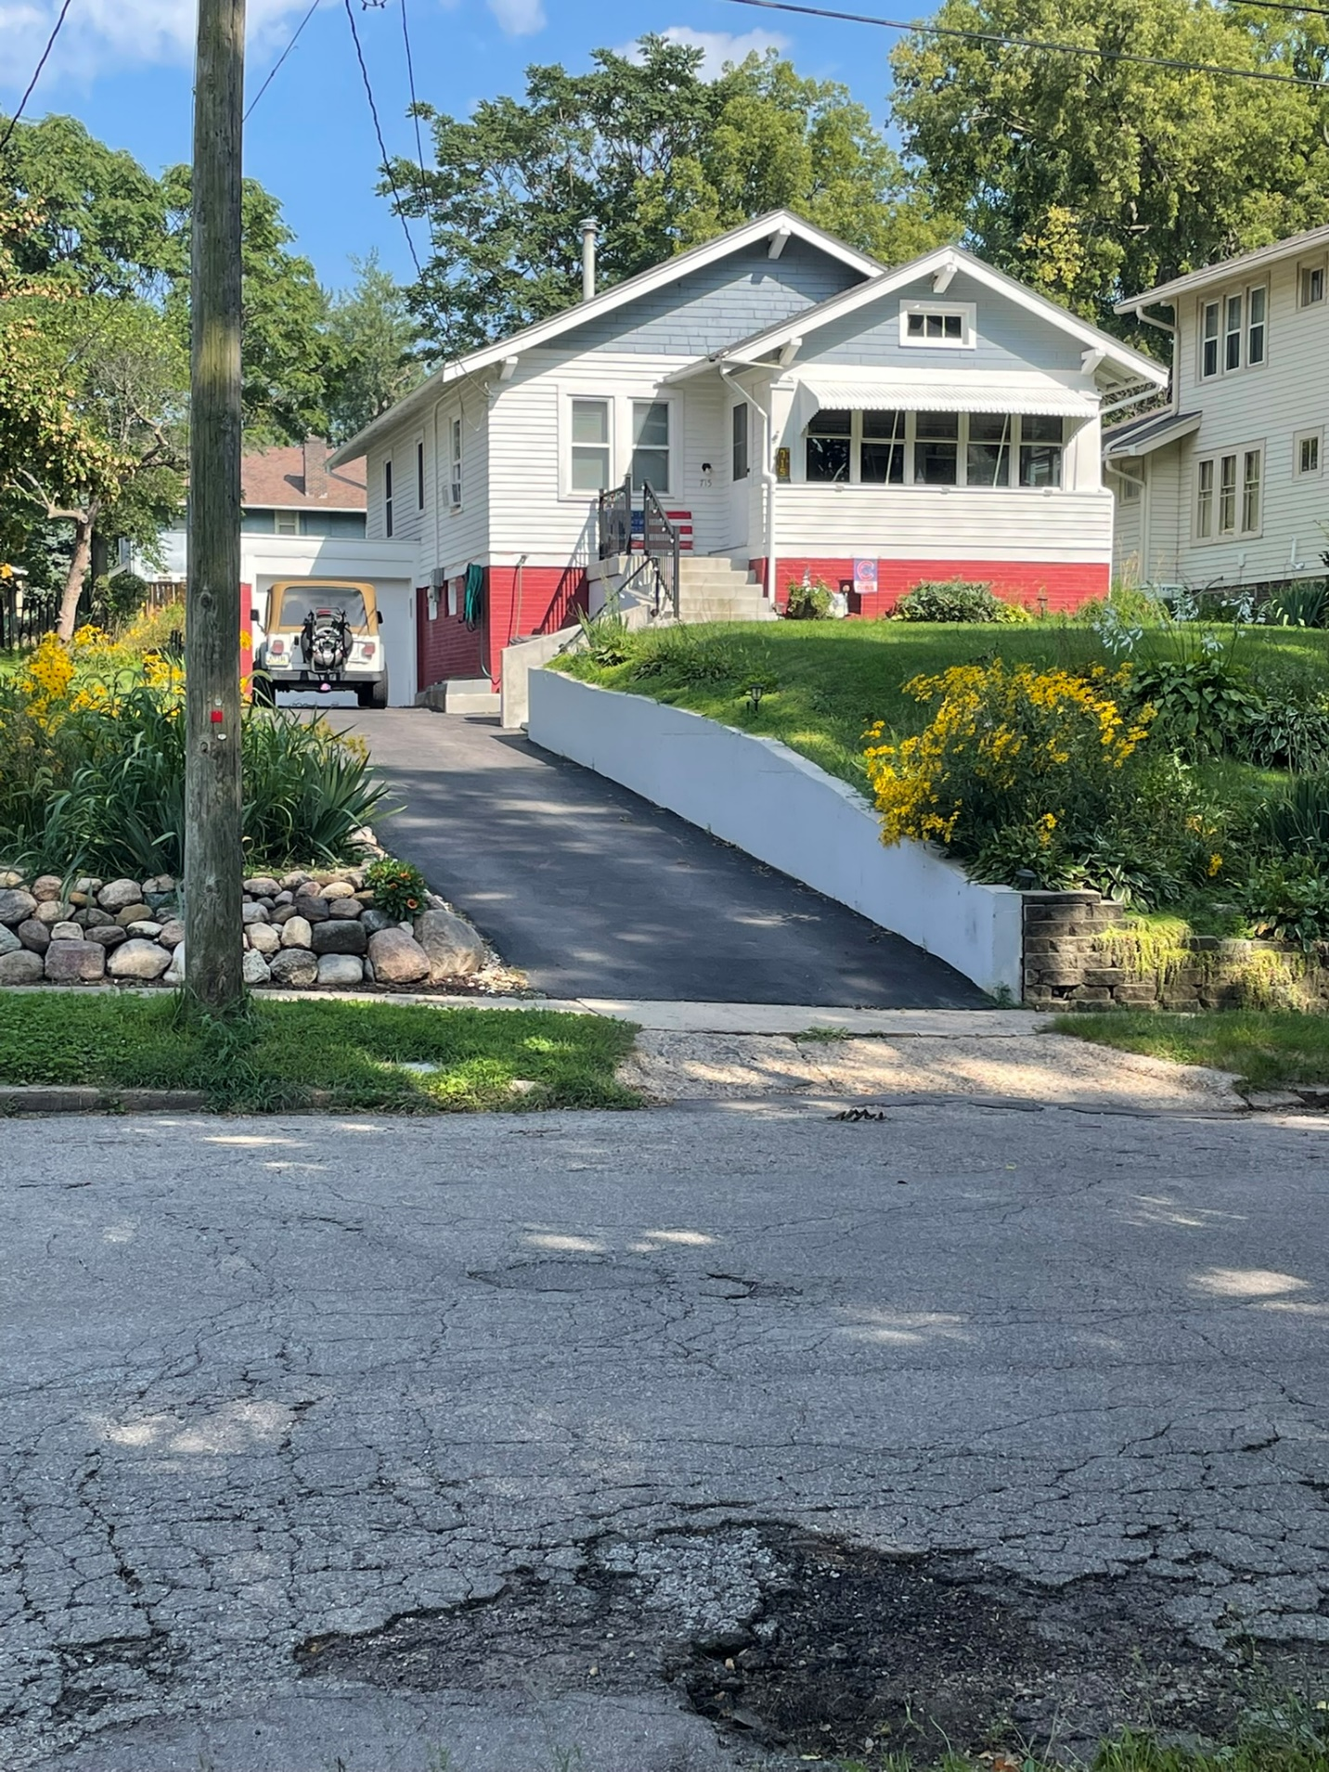

While the roof itself is not very visible, the eaves, fascia, gutters and downspouts look in good condition.

The siding looks clean and in good condition.

The windows are in clean and good condition, with good quality trim around.

Front door is in good condition. Aesthetic touches like prominent house number, attractive external lights, or some form of art or curb appeal is missing and will make it better

Landscaping is basic but well maintained. Retaining wall is in good condition

Driveway is in very good condition.

Conclusion – Given excellent condition of house, the house is scored 2. Aesthetic touches like prominent house number, attractive external lights, or some form of art or curb appeal is missing and will make it better, pushing it to a score of 1.

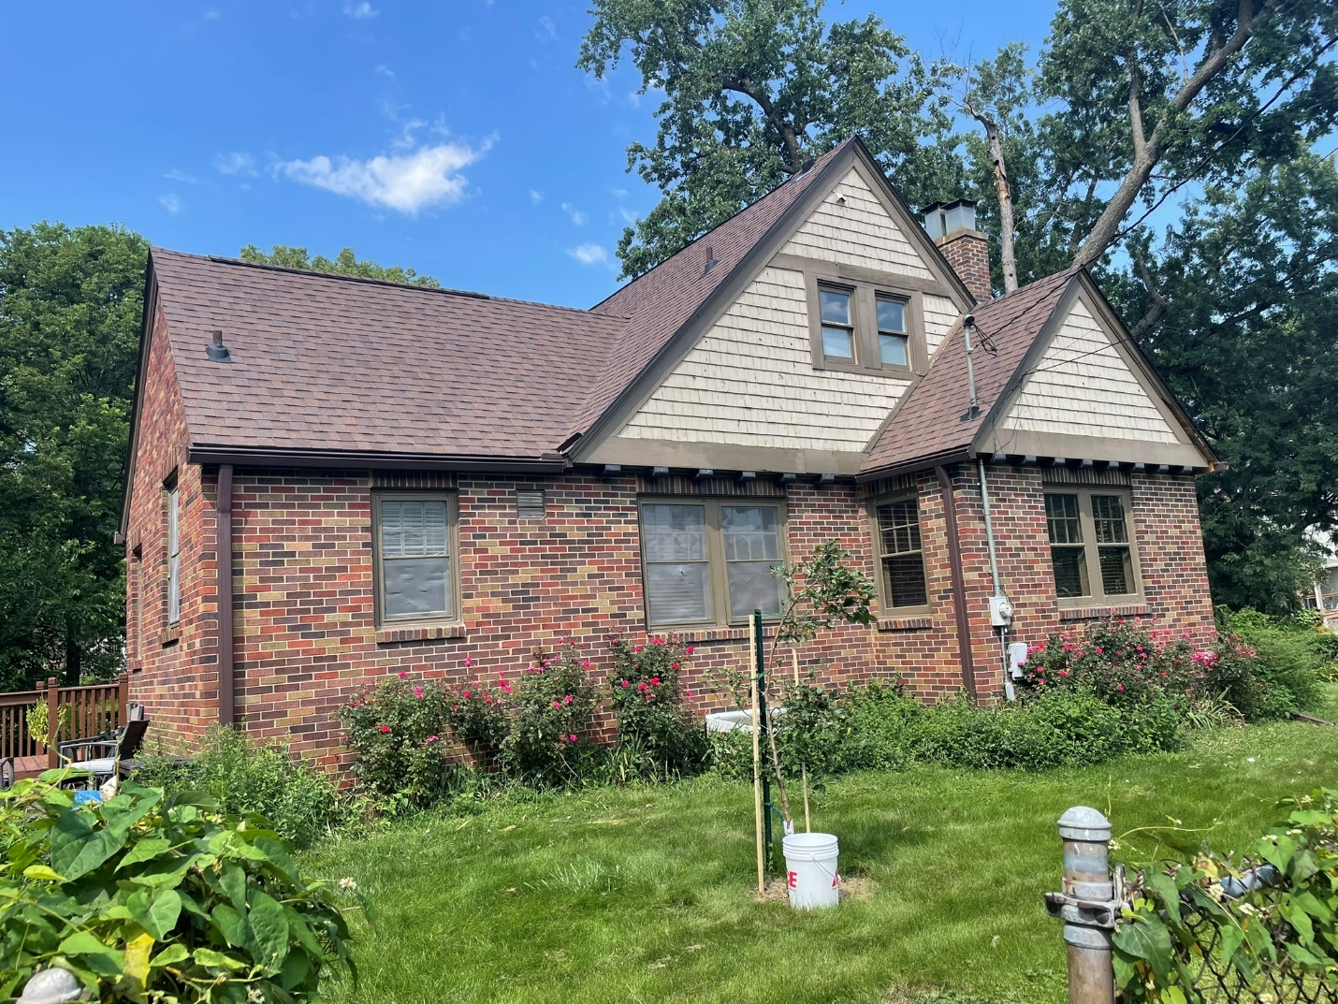

The roof and chimney appear to be in average good condition.

The brick siding appears to be in good condition. But the shake siding in the gables is starting to deteriorate.

The window frames on the first floor look alright, but the screens on them are starting to wear out, with a tear in atleast one window towards the middle.

Landscaping is not maintained.

Conclusion – Given 1-2 red flags, the property is starting to show deferred maintenance issue and the score is 4.

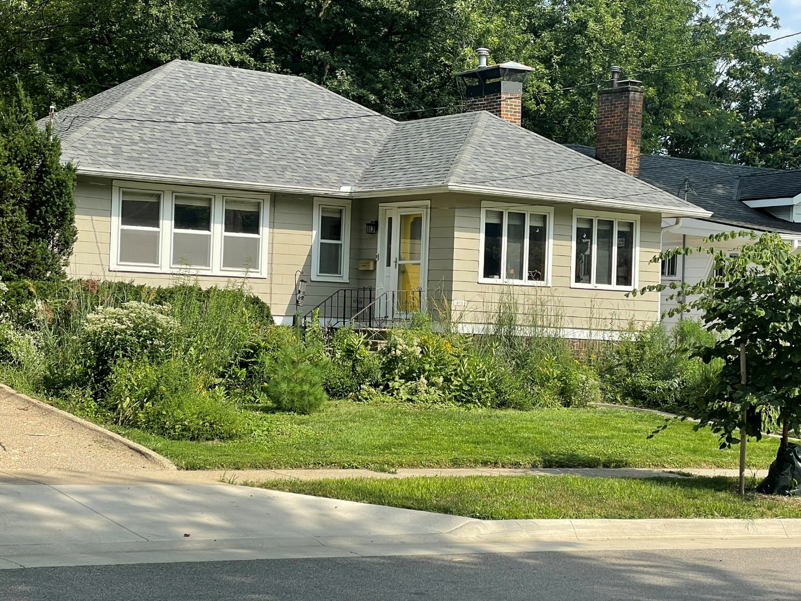

The roof, fascia, gutters and downspouts look in good condition.

The siding looks clean and in good condition.

The windows are in clean and good condition, with good quality trim around.

Front door is in good condition and is painted for an attractive finish.

Landscaping is intentional and generally well maintained.

Driveway is in very good condition.

Conclusion – Given excellent condition of house, the house is scored 2. Aesthetic touches like prominent house number, attractive external lights, or some form of art or curb appeal is missing and will make it better, pushing it to a score of 1.